How to convert the Page numbers in the Ethos manual
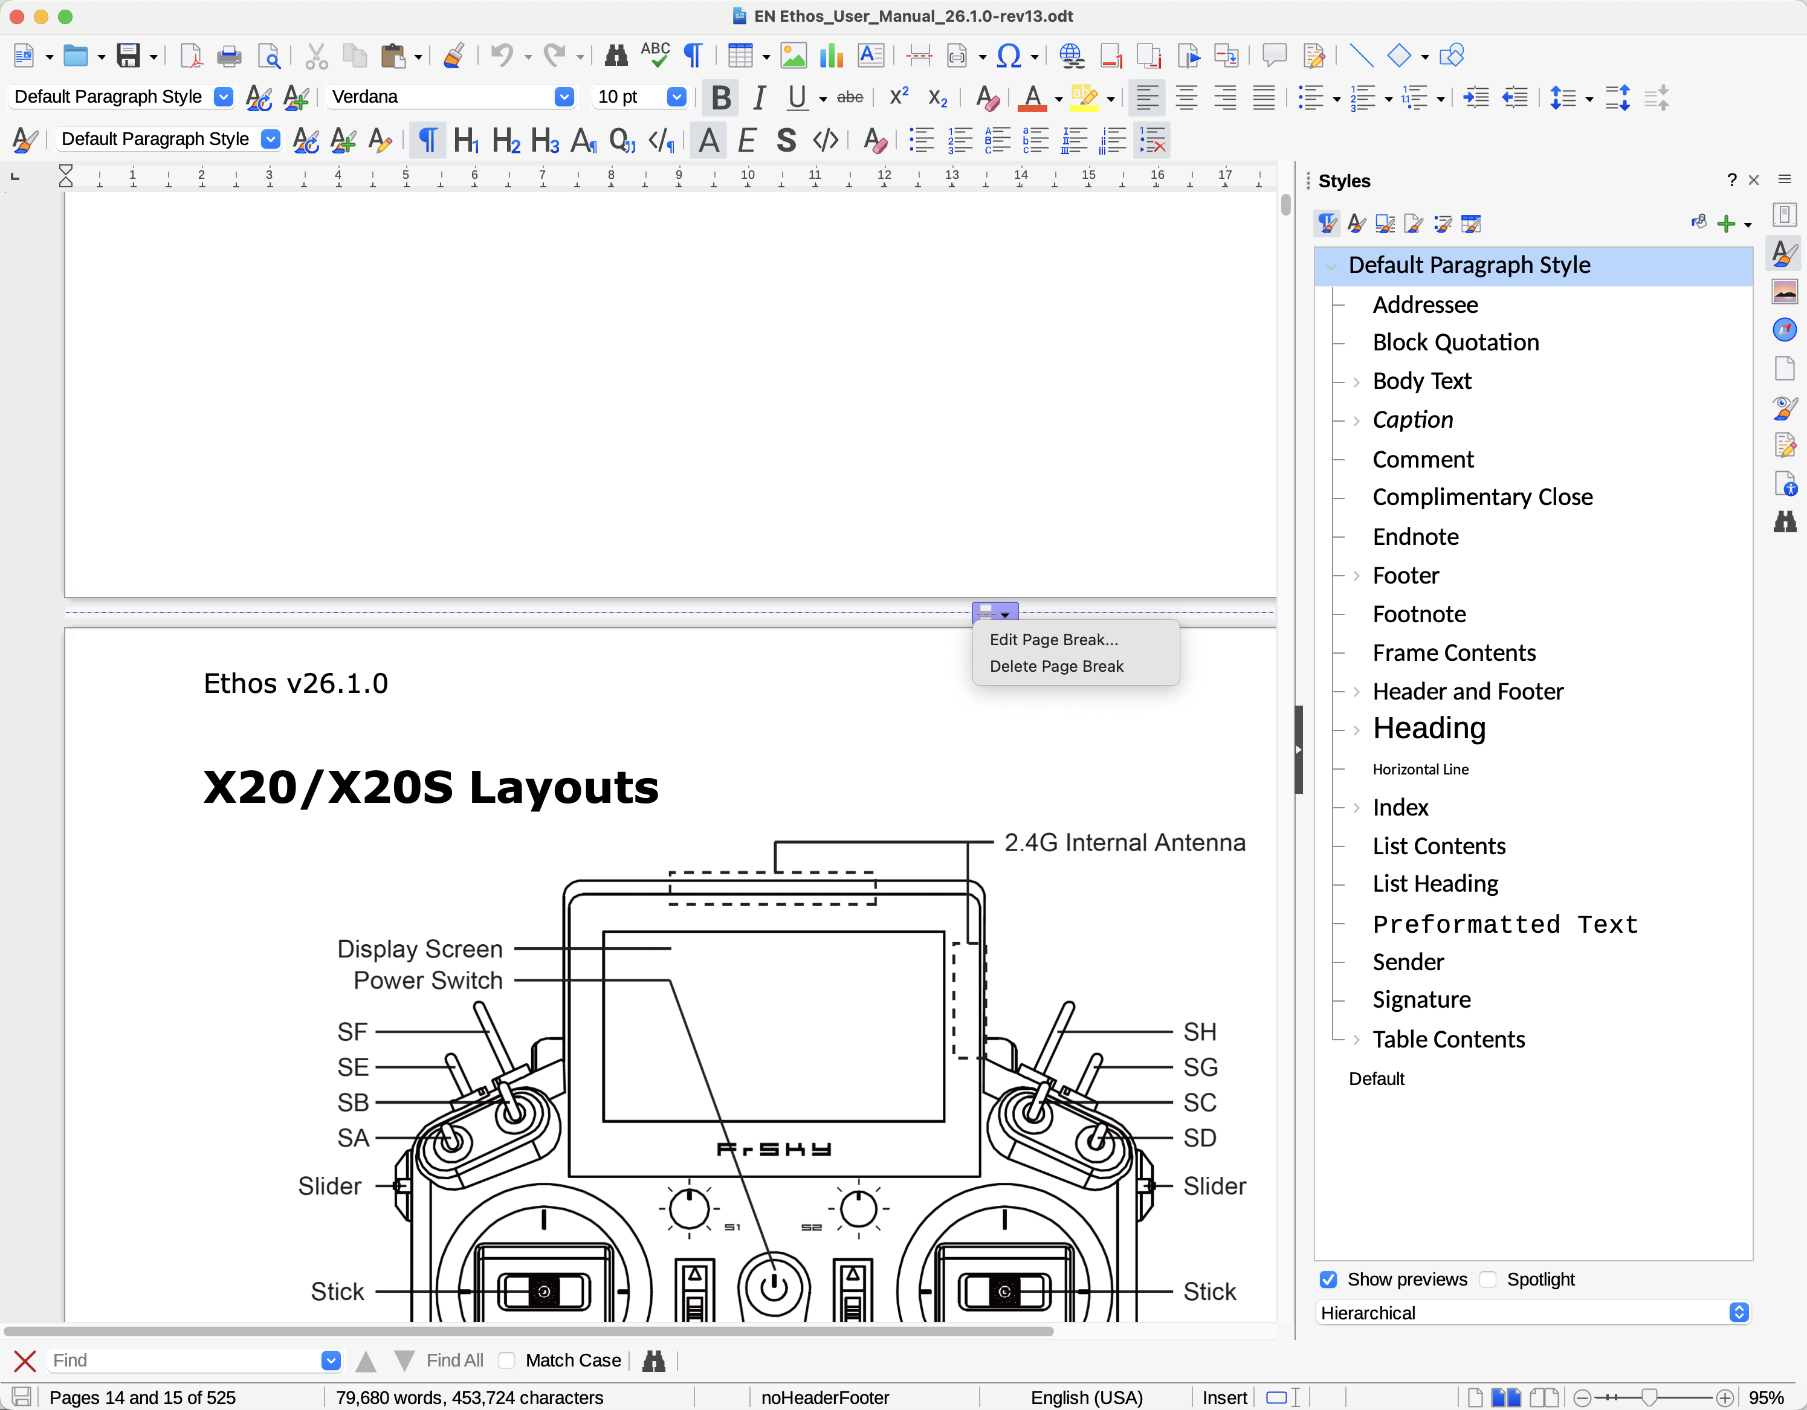

1. Scroll to the page break between the TOC and the X20/X20S Layouts. Double click on it and select ‘Delete Page Break.
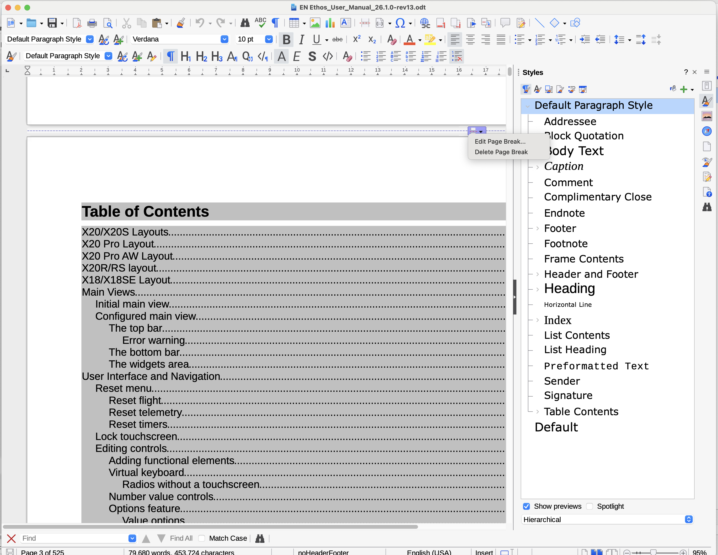
1. Scroll to the page break just before the TOC. Double click on it and select ‘Delete Page Break.

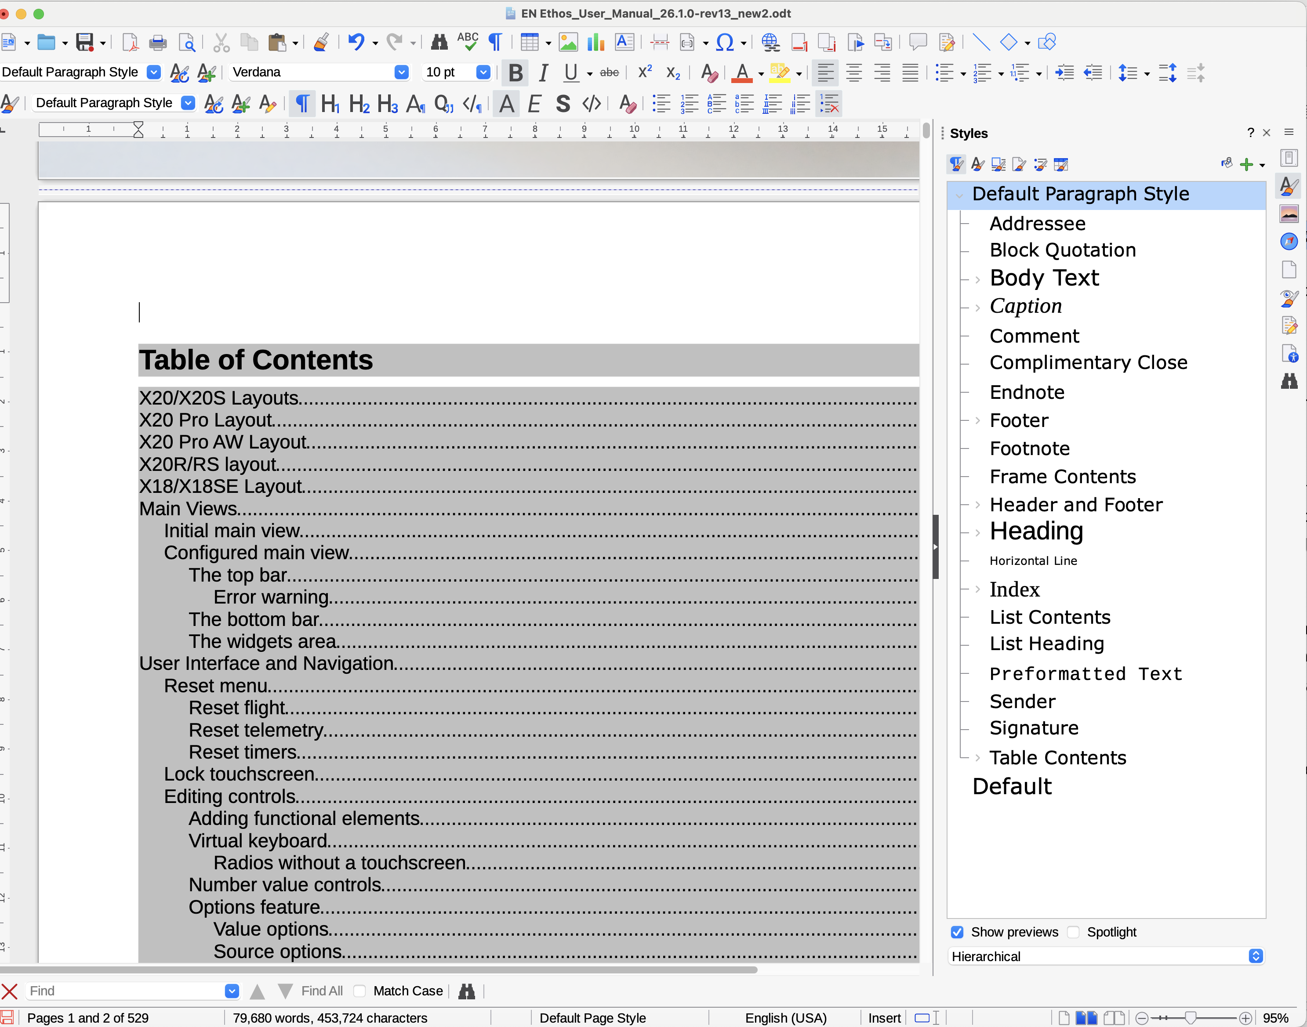

3. Place your cursor above the TOC heading.

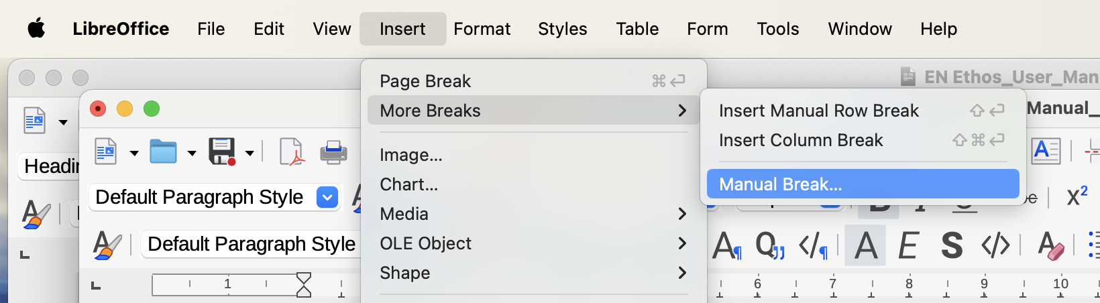

4. Insert / More Breaks / Manual Break….

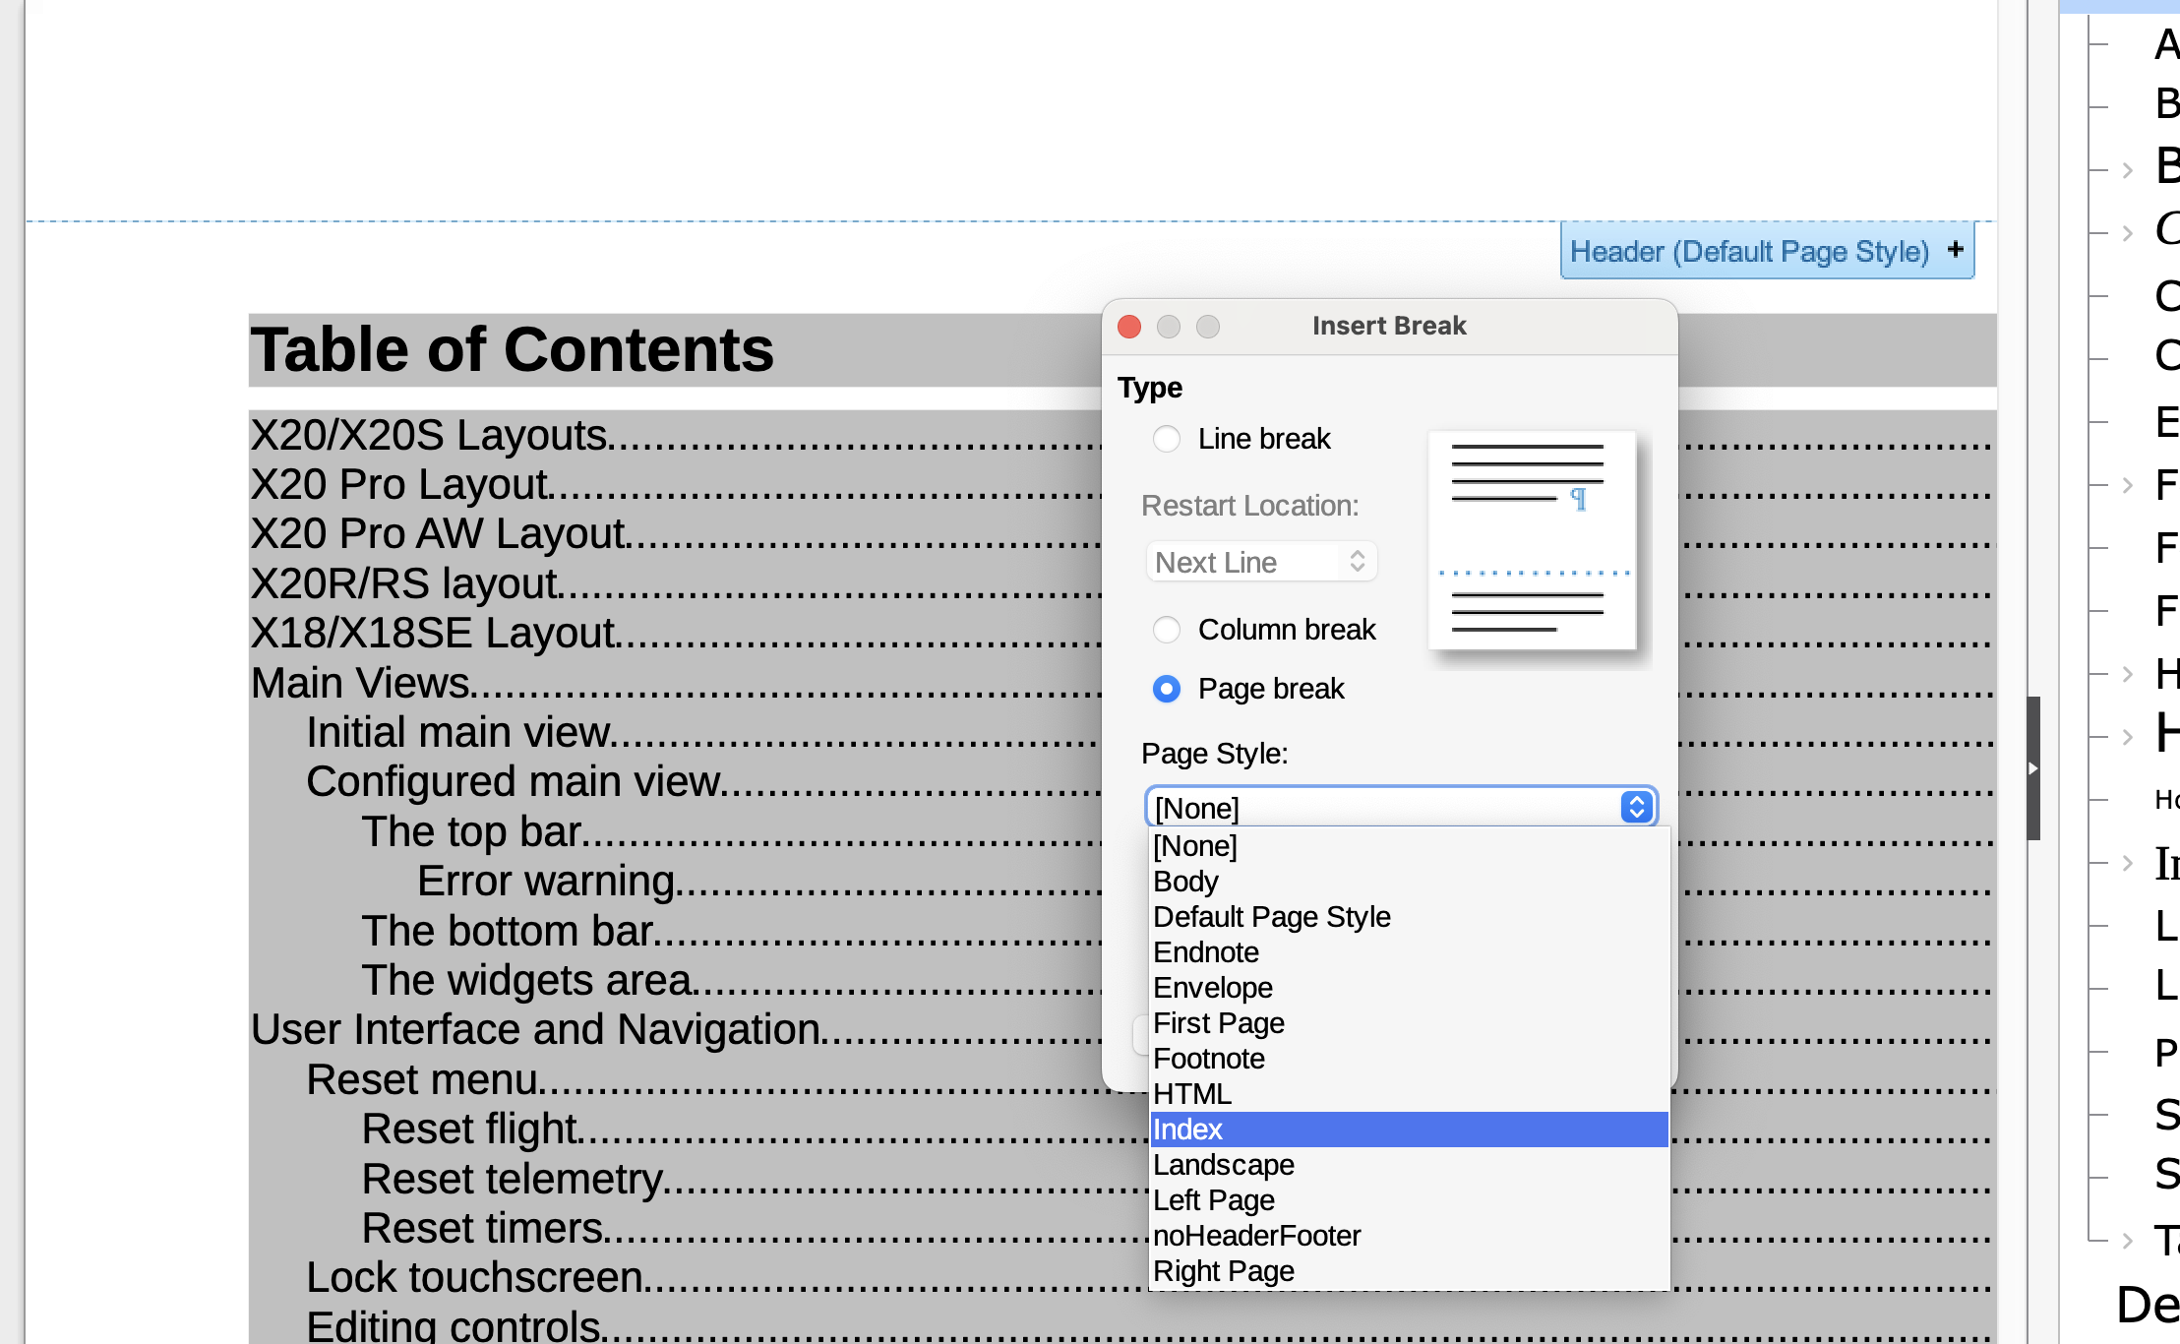

5. Select Page Break and Index.

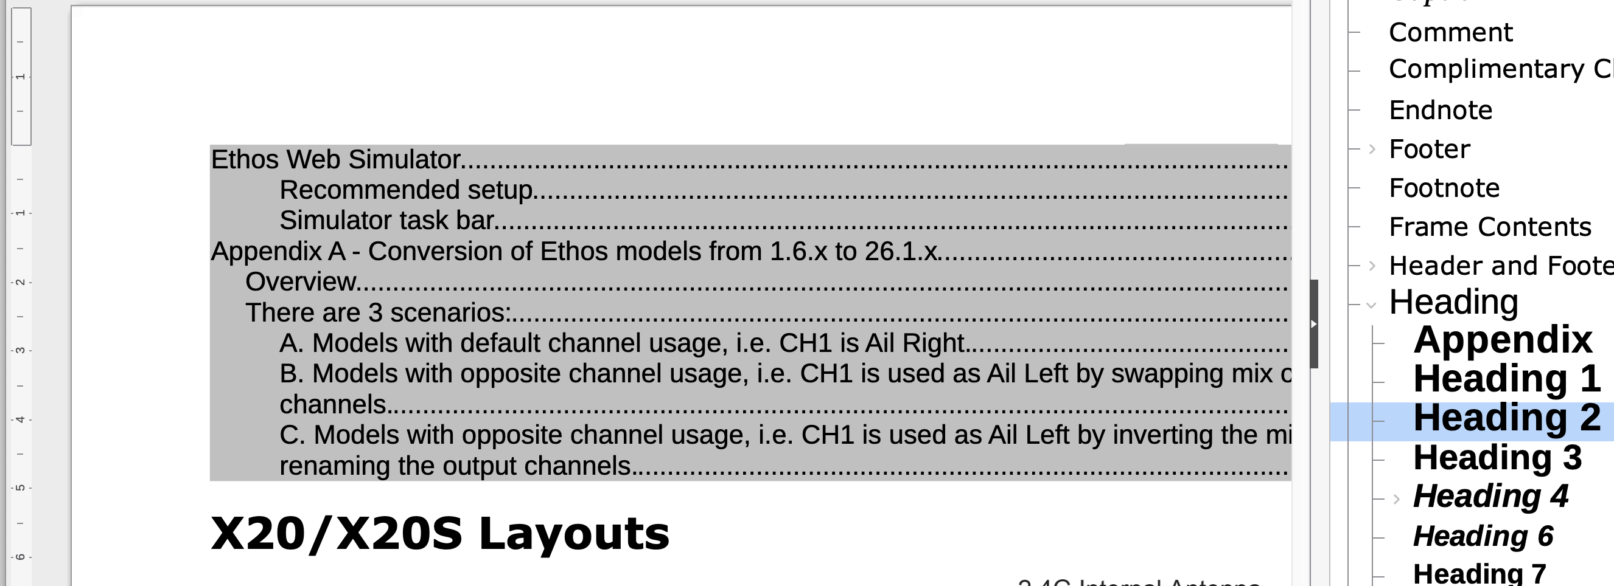

6. Place your cursor at the front of the X20/X20S Layouts heading.
7. Repeat “Insert / More Breaks / Manual Break….”

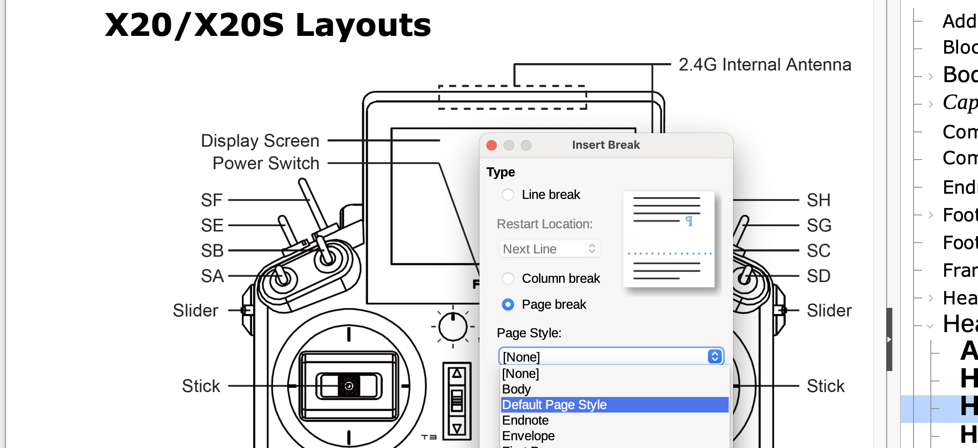

8. Select Page Break and ‘Default Page Style’.

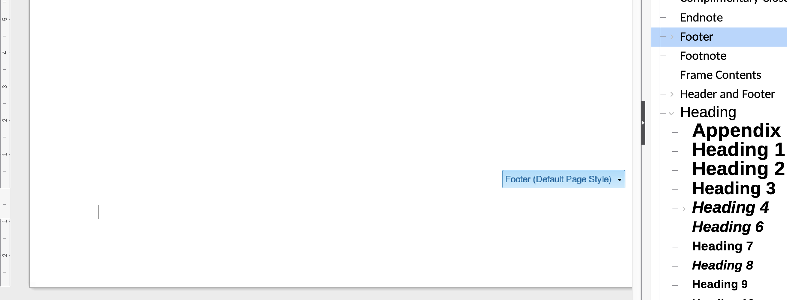

9. Scroll to the bottom of the page, and place your cursor in the footer.

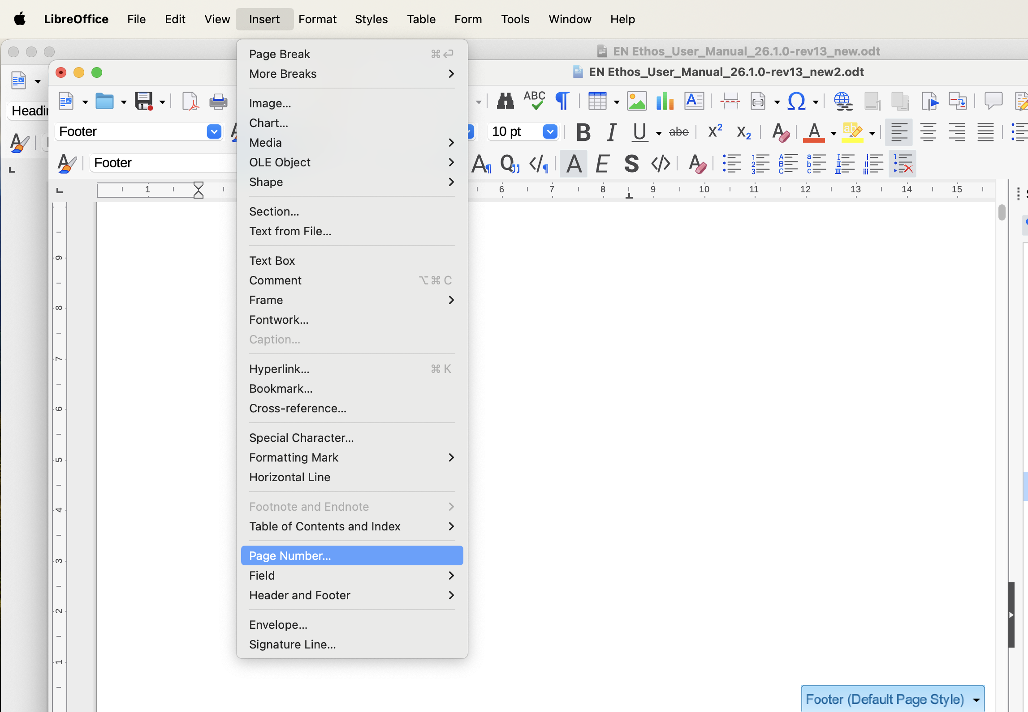

10. Insert / Page Number

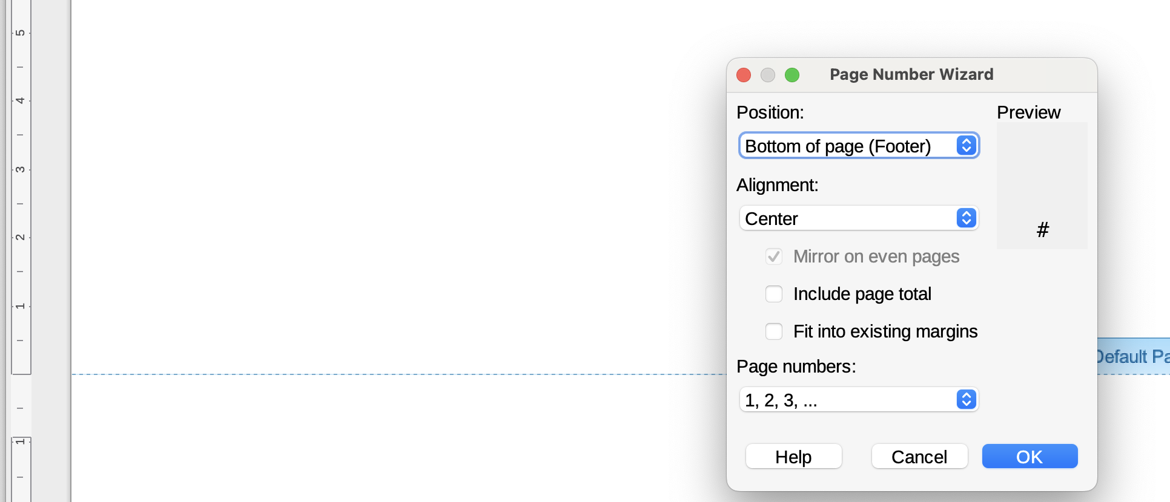

11. Click OK

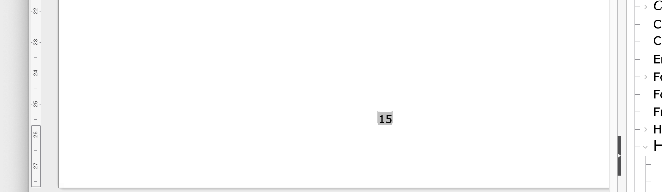

The page that was Page 1 is now Page 15. QED.

